Stages | Considerations | What do we need to do next?
Where are we now?
- Goal performance
- Customer insight
- E-Marketplace SWOT
- Brand Perception
- Internal capabilities & resources
Where do we want to be? (5’s)
- Sell – Customer acquisition & retention targets
- Serve – Customer satisfaction targets
- Sizzle – Site stickiness and visit duration
- Speak – Number of engaged customers
- Serve – Quantified efficiency gains
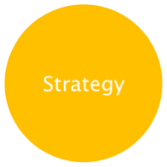 | How do we get there?  - Segmentation, targeting and positioning  - OVP (Online value proposition)  - Sequence (credibility before visibility)  - Integration (consistent OVP) and database  - Tools (web functionality, email etc.)
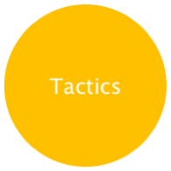 | How exactly do we get there? (Strategy)  - E-Marketing mix including communications mix, social networking, what happens and when  - Details of contact strategy  - E- Campaign initiative schedule
The details of the tactic: who, what and when
- Responsibilities and structures
- Internal resources and skills
- External agencies
How do we monitor performance?
- 5’s + Web analytics – KPI’s
- Usability testing/mystery shopper
- Customer satisfaction surveys
- Site visitor profiling
- Frequency of reporting
- Process of reporting and actions

